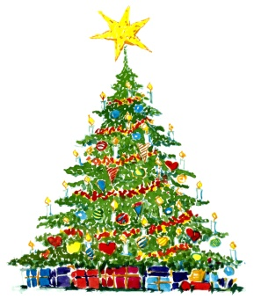
Thornton Christmas Tree Festival
at St. Peter’s Church, Thornton
Saturday 14th and Sunday 15th December 2019
I would like to exhibit a tree at St. Peter’s Church as part of the
Thornton Christmas Tree Festival, which will be
open to the public 14th and 15th December
The theme of the Festival is “Christmas Critters”.
*Please note: Battery-operated lights only please (no electrical leads/cables permitted).
Closing Date for entries: 10th December.

Your name:
Contact details: Email: Phone:
Height of my tree:
*Trees up to 1m (38”) high will be displayed above floor level on boards etc; all trees over 1m high will be displayed on the floor.
Your chosen title on which the tree decoration will be based:
.........................................................................................................................................
Day/time to bring your tree to church and decorate
St. Peter’s will be open on Friday 13th December, 2pm – 7pm for you to bring your tree into the church and decorate it (*battery-operated lights only are permitted). You will be allocated your space on arrival. If you need to come outside of those times, please contact Sue; email suembakewell@gmail.com / telephone 01530 230 643 to arrange a mutually convenient time.
Day/time to take down and remove your tree from church
St. Peter’s will be open on Tuesday 17th December, 2pm – 7pm for you to take down and remove your tree. If you need to come outside of those times, please contact Sue; email: suembakewell@gmail.com or telephone 01530 230 643 to arrange a mutually convenient time.
Festival Prizes:
There will be 3 prizes: the best tree decorated by adults, the best tree decorated by children/family, and the most ingenious or original design.

